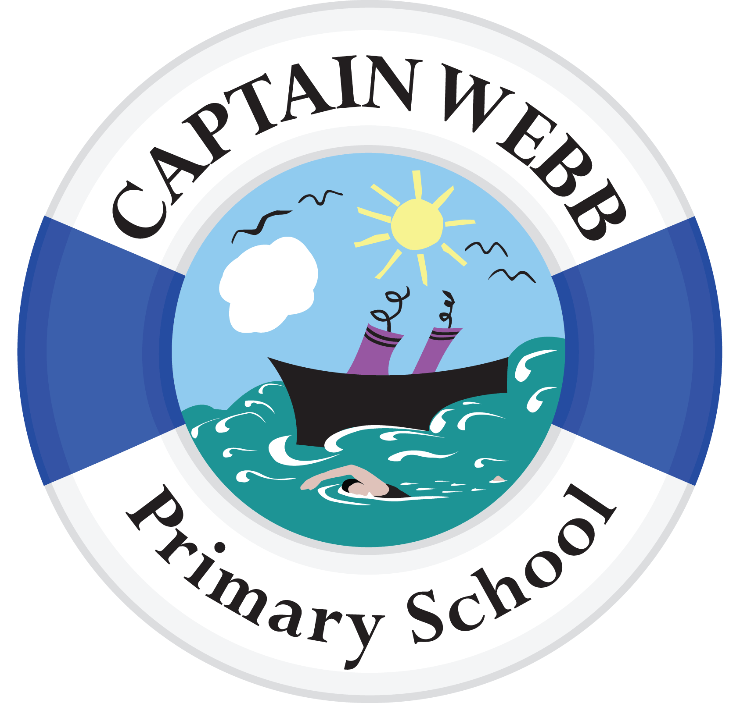
After School Club Application Form

Child
Surname |  |  |  |  |  |  |  |  |  | First Name
Age |  |  |  |  |  |  |  |  |  | Class
Address
Primary Carer
Name
Relationship to child
Home/Work No.
Mobile No.
Email
Are there any custody arrangements we should know about? Y N
Details:
I understand that all sessions I book will be charged for (regardless of my childs attendance) as staffing costs will still be incurred. I agree to these terms:

Signed: ___________________________________ (Parent /Carer) Date: _______________
Requirements:
Day | After School Club Booking (times req.)
Mon
Tues
Wed
Thu
Fri
Emergency release/other authorised adults
I give my consent for my son/daughter to be released to the following person(s) in the event of emergency or illness, if I cannot be contacted:
Person 1
Full Name
Full Address
Relationship to pupil
Contact number
Person 2
Full Name
Full Address
Relationship to pupil
Contact number

Medical Information
Name of GP
Practice Address
Has your child any:
Illnesses/Disabilities
Allergies
Medications
Dietary Requirements

CONSENTS
Please indicate whether you have given your consent (for your child be included in the following activities), by ticking the box on the right-hand side; and sign and date the form on the last page. Where no tick is present it will be assumed no consent is given.
On site Activities
Use the internet in line with the school’s acceptable usage policy
View films and video clips rated PG
Take part in food preparation/cooking and tasting activities

Medical Consents
Captain Webb Primary School has a duty of care, under *Keeping Children Safe in Education (DfE) 2020 and **HSE Guidance, to ensure that any child who receives an injury whilst in our care will be treated by a trained first aider. If it is felt necessary we will call for emergency medical services to ensure the safety and wellbeing of your child.
In the case of first aid being administered we will ensure a form is sent home to advice parents/carers of any treatment applied. If the injury is deemed to be more serious the parent/carer will be called. In urgent situations we will always endeavour to contact the parents/carers to advise of the situation but we will call for medical aid first. Please see our First Aid Policy at https://www.captainwebbprimary.org/policies
If your child has medical condition/allergies the school will display their photo, name, class, and details of their allergy in non-public, prominent positions (such as office, staff room and kitchen – in case of food allergy). We do this under the ‘Keeping Children Safe in Education’ and H&S guidance to ensure all staff, especially those new to the setting, are visually able to identify those children affected.

If you have any concerns with respect to any of these policies, please contact the school office on 01952 386770, or by email at A2174@taw.org.uk, one of the office staff will be happy to deal with your concerns.
*you can download a copy at https://www.gov.uk/government/publications/keeping-children-safe-in-education--2,

**Visit http://www.hse.gov.uk/services/education/index.htm

Communication
Captain Webb Primary School keeps in touch with parents via several types of media.
Personal messages/contact is completed via:
- Face to Face
- Phone
- Email
- Text
- Letter
General information is also disseminated via:
- Twitter https://twitter.com/CaptWebbSchool
- Facebook https://en-gb.facebook.com/captainwebbprimaryschool
- Website www.captainwebbprimary.org
- Weekly Newsletter.

Please ensure you have given us the correct contact details and that you keep us informed of any changes.

You can inform us of changes either by email, or by completing a form at the school office.

Please sign and date the form before returning it to the school office

Signed: ................................................................................ Date: ....................

Print Name: …………………………………………………….

